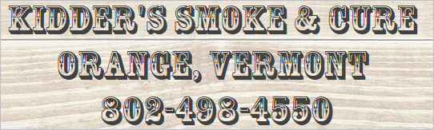

Lamb/Goat Cut Sheet
Name: ____________________________
Phone #: __________________________
# of Animals: _____________
Circle your Choice
Legs: Bone-In Whole___ Bone-In Split (cut in half)
Boneless Whole ____ Boneless Split
Loin: Chops______ # Per Package_3,4,5,6___ Thickness ½”, ¾”, 1” (circle one)
Roast______ Approx Size: _________lbs
Racks: Chops # Per Package _3, 4, 5, 6____Thickness ½” , ¾” 1” (circle one)
Roast Approx Size ________lbs
Stew: Yes----NO (1# pack)

Shoulder:
Steaks Whole Bone-In Whole Boneless Ground (Circle one)
Ground Lamb: Yes -----NO
Shanks: Yes-----No
Special Request:__________________________________________________________________________________________________
----------------------------------------------------------------------------------------------------------
(Plant Use Only)
Animal Hanging Wt.:
1__________ 2__________ 3_________
4__________ 5__________ 6_________

