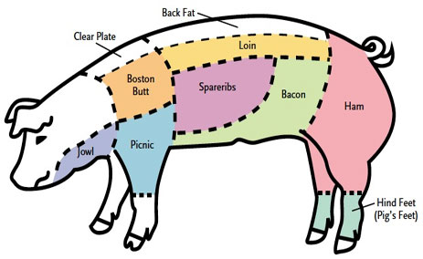
Cut Sheet
Name:

Pig WT
½-1___________
½-2___________

Ham 2
#1-Whole/Sliced-Fresh or Smoked__1/2-3/4-1”___________________________________________wt=________
#2-Whole/Sliced-Fresh or Smoked__1/2-3/4-1”___________________________________________wt=_________

Bacon 2
#1-Fresh or Smoked- Whole or Sliced Pak Size 1lb, 2lb, Bulk________________________________ wt=_________
#2-Fresh or Smoked- Whole Or Sliced Pak Size 1lb, 2lb, Bulk _______________________________ wt=_________

Ribs -Yes or No Whole Rack_______ Country Ribs Yes Or No__PC Per Pack 4-5-6-7-8
Loins 2
#1-Bnls or Bone in chops or roast Pc per pack 2-3-4-5-6__________________________________Roast LB________
#2-Bnls or Bone in chops or roast Pc per pack 2-3-4-5-6__________________________________ Roast LB _______
Shoulders 2
1-Fresh/Smoked/Roast______________________________________________________________ wt=_________
2-Fresh/Smoked/Roast ______________________________________________________________ wt=_________
Neck Sausage – Roast__________lb
Feet & Jowl Fresh/Grind/ Smoke______________________________________________________wt=_________

Sausage: Breakfast, Hot, Sweet
Wt=_________________________
Bones: YES/NO
Lard: YES/NO

